

**SCHOOL OF COMPUTING SCIENCE**

**&ENGINEERING (2021-25)**

**(DATA ANALYTICS EXCEL TABLEAU)**

***SUBMITTED BY SUBMITTED TO***

**Shivam Dwivedi (21SCSE1010662)**

Shivam Dwivedi(21SCSE1010662)

***EXPERIMENT NO-1***

# INSTALLING DATA ANALYSIS TOOL IN EXCEL

***AIM:*** *Installing Data Analysis Tool in Excel.*

***Procedure***: Step 1: Click on the file tab.

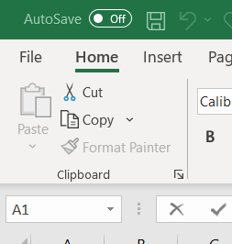

Step 2: Click Option then click Add-ins.

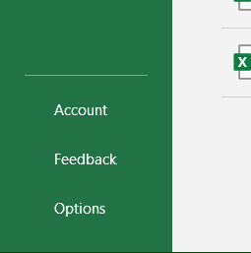

Shivam Dwivedi(21SCSE1010662)

Step 3: In the manage box, select Excel Add-ins and Click GO

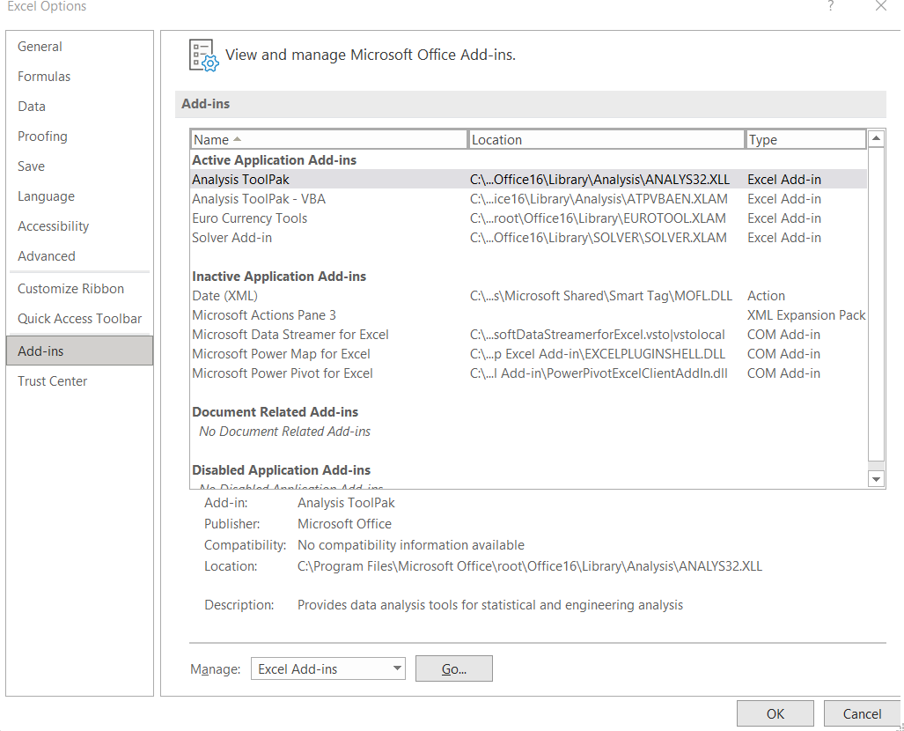

Step 4: In Add-ins select the Analysis tool pack and Click OK. (Fig.4)

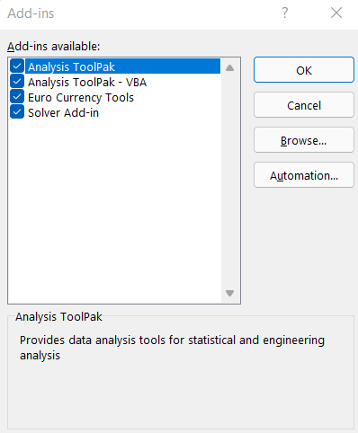

Step 5: Finished installing Data Analytics tool in Excel. (Fig.5)

Shivam Dwivedi(21SCSE1010662)

***P.NO-2***

# ANALYSIS USING FORMULAS IN EXCEL

***AIM:*** *To find out the common functions (i.e., Sum, Avg. etc) on a given excel sheet.*

***Procedure***: 1. First open a new excel and fill it by adding Some details (i.e., Name, Subject Name, Marks, Etc.) in row and column format.

1. Create new fields like (Sum, Avg., Max, Min, etc.)
2. Fill them by the help of formula bar.
3. Complete it and also innovate it (by adding Background colours, **B**, *I*, U, etc.)

***Output:*** As shown in Figure.

**Result:** Analysis Completed.

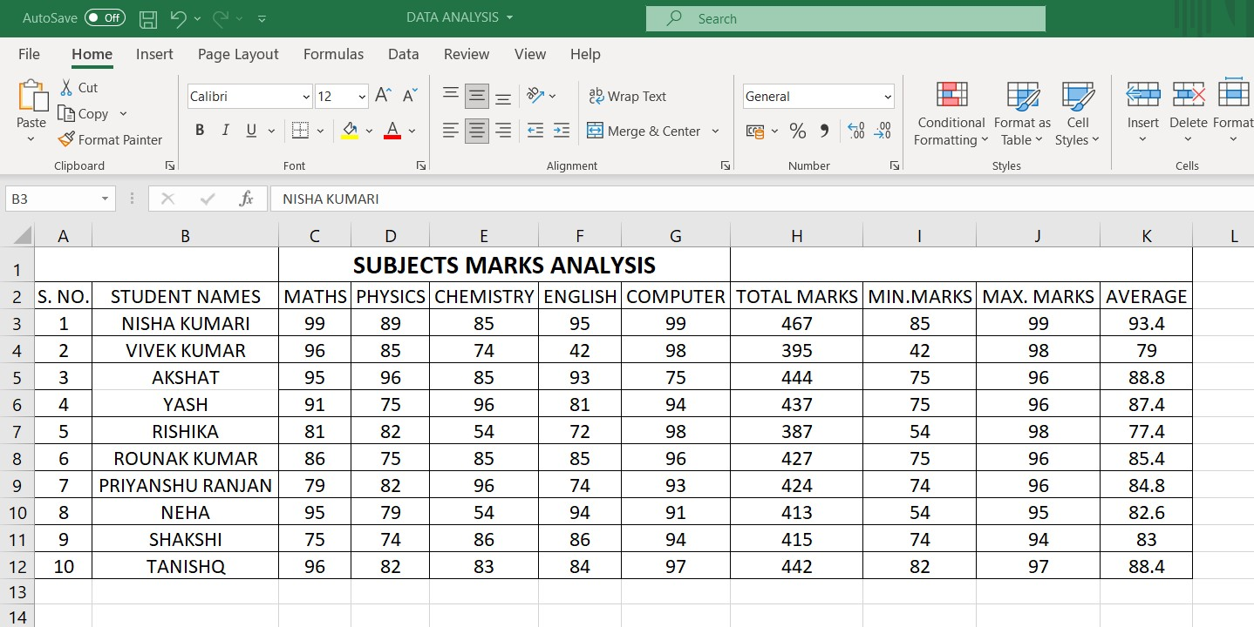

Shivam Dwivedi(21SCSE1010662)

***EXPERIMENT NO-2***

# TO PERFORM BASICS OPERATIONS AND FUNCTIONS USING EXCEL.

***AIM:*** *To find out common function (i.e., Sum, Max, Min, Count no.) and a bar graph on a given excel sheet.*

***Procedure***: 1. First open a new excel and fill it by adding Some details (i.e., Name, Marks

etc.) in row and column format and to calculate the bar graph.

1. Create new fields like (Sum, Max, Min, Count no.).
2. Fill them by the help of autosum.
3. Complete it and innovate it (by adding

**B**, *I*, U, etc.)

***Output:*** As shown in Figure.

**Result:** Analysis Completed.

Shivam Dwivedi(21SCSE1010662)

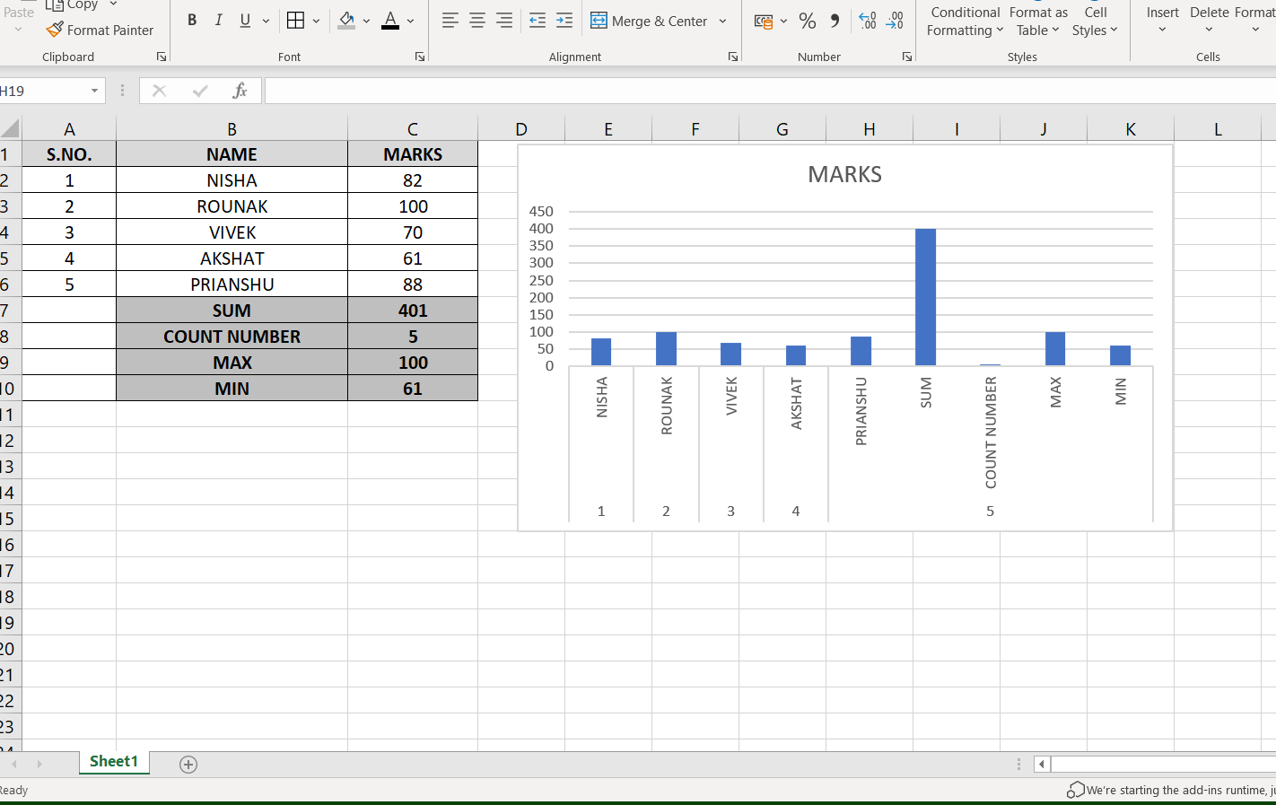

Shivam Dwivedi(21SCSE1010662)

***EXPERIMENT-3***

***TO PERFORM BASICS MATHEMATHEMATICAL FORMULAS AND FUNCTIONS IN EXCEL***

**AIM:** To find out basic mathematical function using excel (i.e. sum, percentage, left, mid, right, concentrate, rand between, time etc) on a given excel sheet.

## PROCEDURE:

1. Click on the file tab.
2. Then, fill it by adding some details (i.e. name, marks) in row and column format and to calculate the percentage and IF.
3. Create new fields using different functions like max, min, count, concatenate etc.
4. Fill them with the help of formula bar, the excel provide calculation of all the marks.

**OUTPUT:** As shown in the figure.

**RESULT:** Analysis is completed.

Shivam Dwivedi(21SCSE1010662)

**EXPERIMENT-4**

***TO PERFORM FILTERING OPERATIONS, PIVOT TABLES AND CHARTS USING EXCEL***

## PROCEDURE:

### To filter data:

1. Select the data tab then locate the sort and filter group.
2. Click the filter command.
3. Then, drop down will appear in the header of each column.
4. Click the drop-down arrow that we want to filter.
5. The filter menu will appear.
6. Uncheck the boxes that we don’t want to view and

check the boxes next to the data that we want to view.

1. Click OK. All the data will be filtered.

## PIVOT TABLE:

1. Select the cell that we want to create.
2. Select insert and then choose pivot table and choose the data that we want to analize.
3. Select a table or range. In table verify the cell range.
4. Now, select pivot table where we want to be placed.
5. Select new worksheet to place the pivot table and then select the location where we want to pivot table to appear.
6. Select OK button.

Shivam Dwivedi(21SCSE1010662)

## BAR CHART:

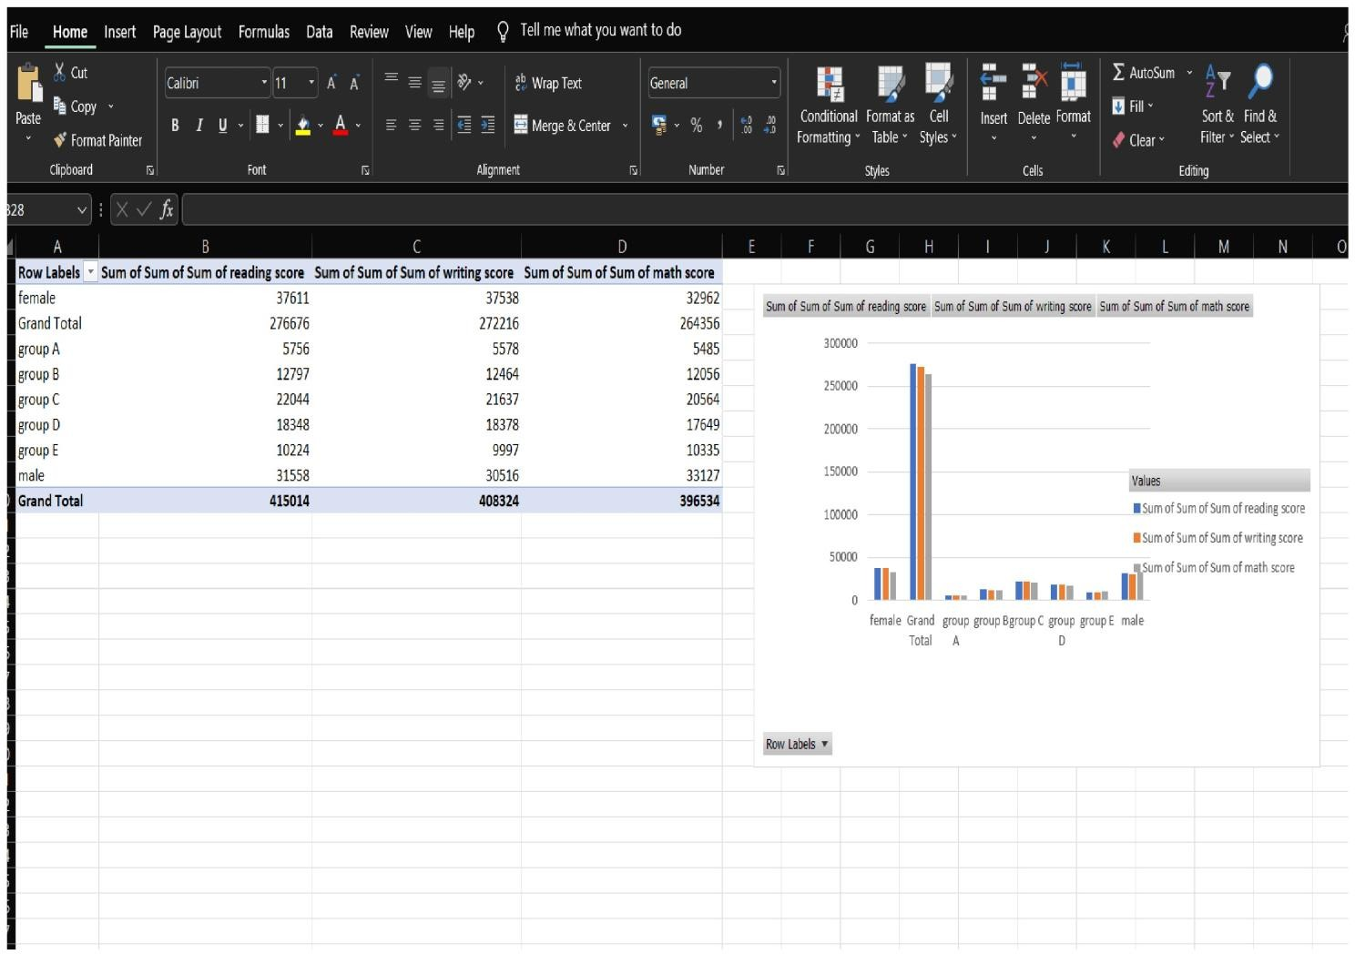

* 1. Arrange the data in rows/columns on the worksheet.
  2. Select the data. 3.

1. On the insert tab, Click the bar chart.
2. Point the mouse on each of the icons then double click the chart type that suits our data.
3. A bar is inserted.

Shivam Dwivedi(21SCSE1010662)

***EXPERIMENT-5***

***TO PERFORM HISTOGRAM IN EXCEL***

### PROCEDURE:

1. Select the entire datasheet.
2. Click the insert tab.
3. In the charts group, click on ‘Insert Chart Option’.
4. On the Histogram group, Click on the Histogram chart icon.

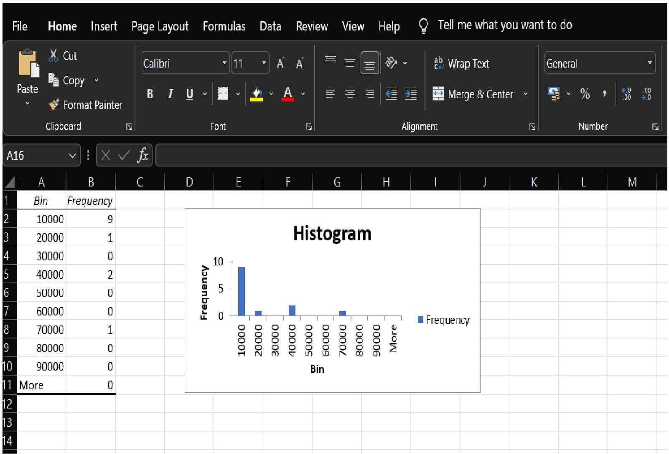

Shivam Dwivedi(21SCSE1010662)

***EXPERIMENT-6***

***TO PERFORM WITH MOVING AVERAGE.***

# PROCEDURE:

1. Go to Data tab.
2. Click on the data analysis in the analyses group.
3. Data analysis dialog box will appear.
4. From the analysis drop down menu select the moving average and click on OK button.
5. We will get another moving average dialog box will appear.
6. Click on Input range. Then, select the range from which you want to get the input.
7. Tick on output range & select the cell where you want to show.
8. Tick on the chart output in the box.
9. Click on OK button.**OUTPUT:**
10. As shown in Figure.

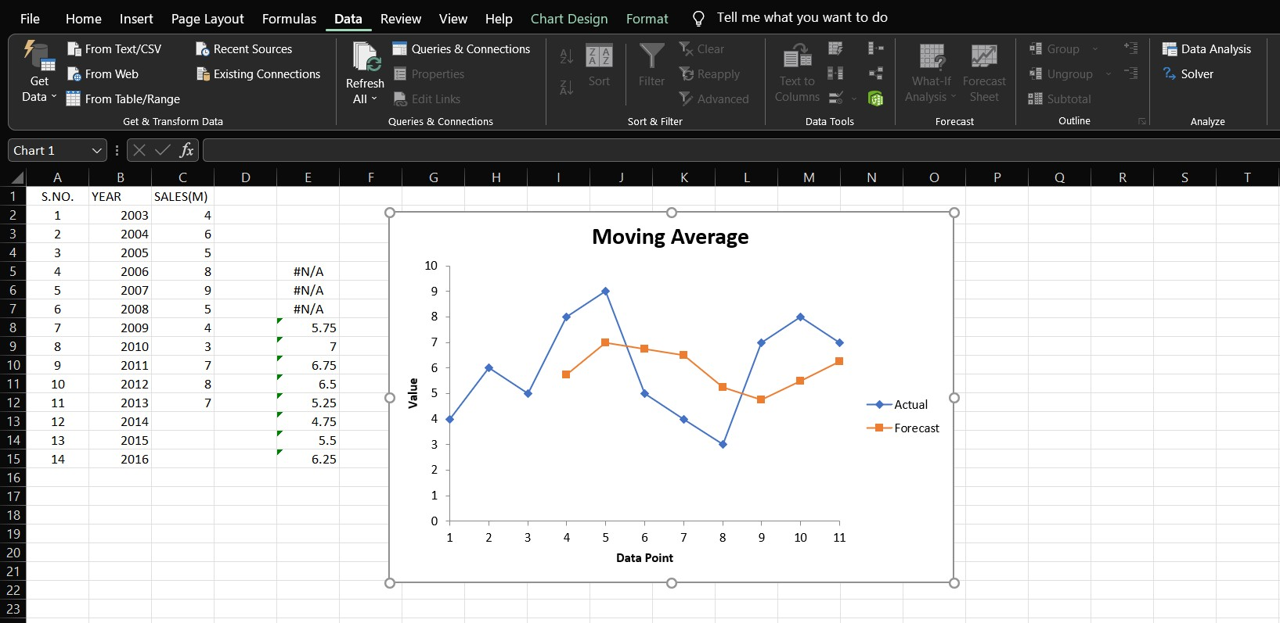

Shivam Dwivedi(21SCSE1010662)

***EXPERIMENT-7***

***TO PERFORM WITH EXPONENTIAL SMOOTHING. PROCEDURE:***

1. Go to data tab.
2. Click on Data Analysis in the analyses group.
3. Data analysis dialog box will appear.
4. From the analysis tool drop down menu select the exponential smoothing and click on OK button.
5. An exponential smoothing dialog box will appear.
6. Click on Input range. Then, select the range from which you want to get the input.
7. Then, tick on Chart Output.
8. Click on OK button.

**OUTPUT:** As shown in figure.

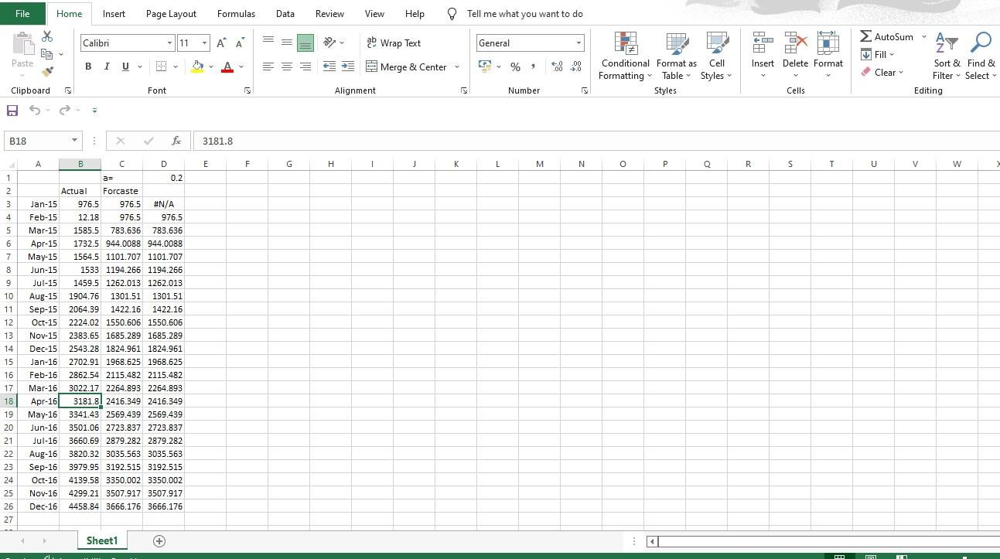

Shivam Dwivedi(21SCSE1010662)

Shivam Dwivedi(21SCSE1010662)